Identification of an Unknown – “A”
Ashtyn Casciano
November 28, 2023
CHEM 2081-001

Introduction
The goal of this experiment is to identify an unknown compound (“A”) with the use of NMR, GCMS, and FTIR. These three types of data are necessary for analyzing a chemical compound’s purity and even for identification of an unknown. All of these spectrums are great tools for minimizing error in an experiment.
Materials and Methods
NMR, or nuclear magnetic resonance, is a powerful tool in determining the structure of a compound. NMR is used by studying the interaction between electromagnetic radiation and the nuclei of atoms. In order to obtain a proton NMR spectrum of a compound, the compound must first be dissolved in a solvent and placed in a glass tube. This tube is then inserted into the NMR spectrometer. It is important to make sure the solvent does not contain any protons, or else the spectrum will be overwhelmed with signals and thus unreadable. There are three important characteristics of the proton NMR spectrum. They are: the location of each signal, the area under each signal, and the shape of the signal. The location of each signal indicates the electronic environment of the protons. The area under each signal indicates the number of protons that give rise to each signal. Finally, the shape of the signal indicates the number of neighboring protons.
GCMS, also known as mass spectrometry, is the study of the interaction between matter and an energy source (that is not electromagnetic radiation). This method is primarily used to determine the molecular weight as well as the molecular formula of a compound. In using a mass spectrometer, a compound is first vaporized and converted into ions. These irons are then separated and detected. The most common technique, electron impact ionization (EI), involves bombarding a compound with high-energy electrons. When one of these high-energy electrons strikes the targeted molecule, one of the molecule’s electrons is ejected.
FTIR, or infrared spectroscopy, utilizes vibrational excitation of bonds in a molecule. These vibrations can be stretching or bending, and each can happen in a number of ways. In an IR spectrometer, a sample is irradiated with frequencies of IR radiation. The frequencies that pass through, not the ones absorbed, are detected. The plot of percent transmittance is known as an absorption spectrum and all the signals point downwards on the IR spectrum. On an IR spectrum, some signals will be much stronger than others, i.e., some bonds absorb IR radiation very efficiently. Overall, infrared spectroscopy is a great tool for rapidly determining which functional groups are present in an unknown compound.
Data
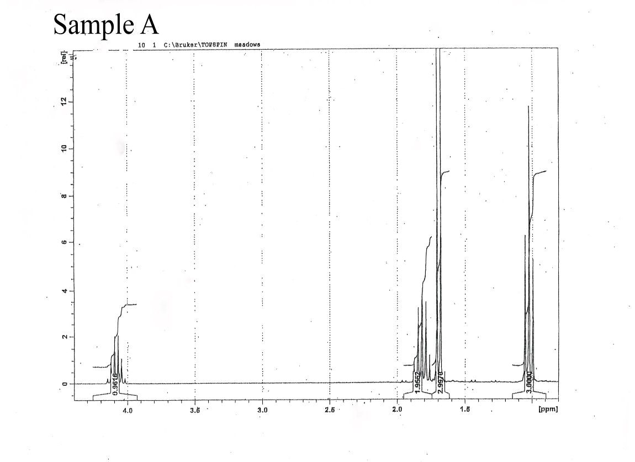
HNMR
GCMS
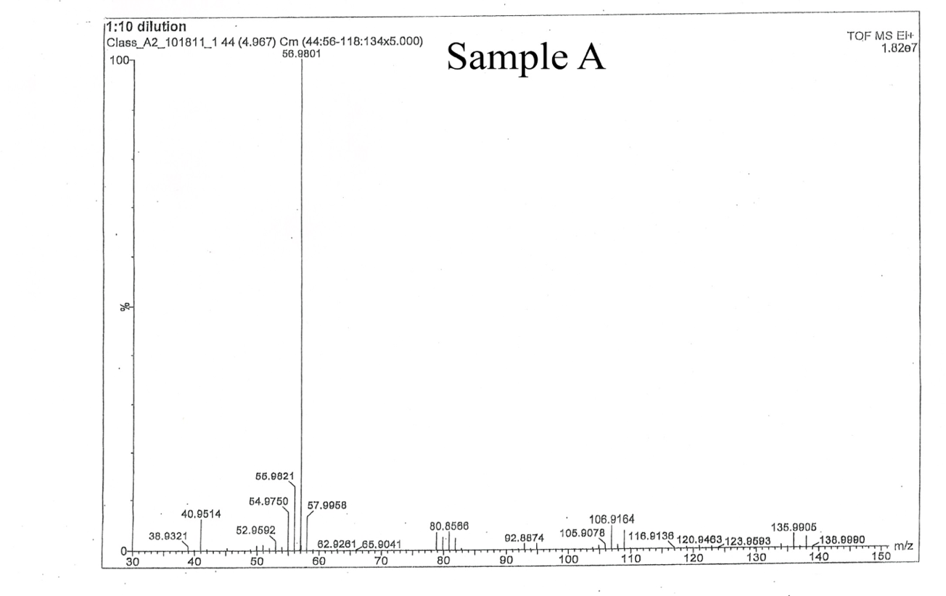
FTIR
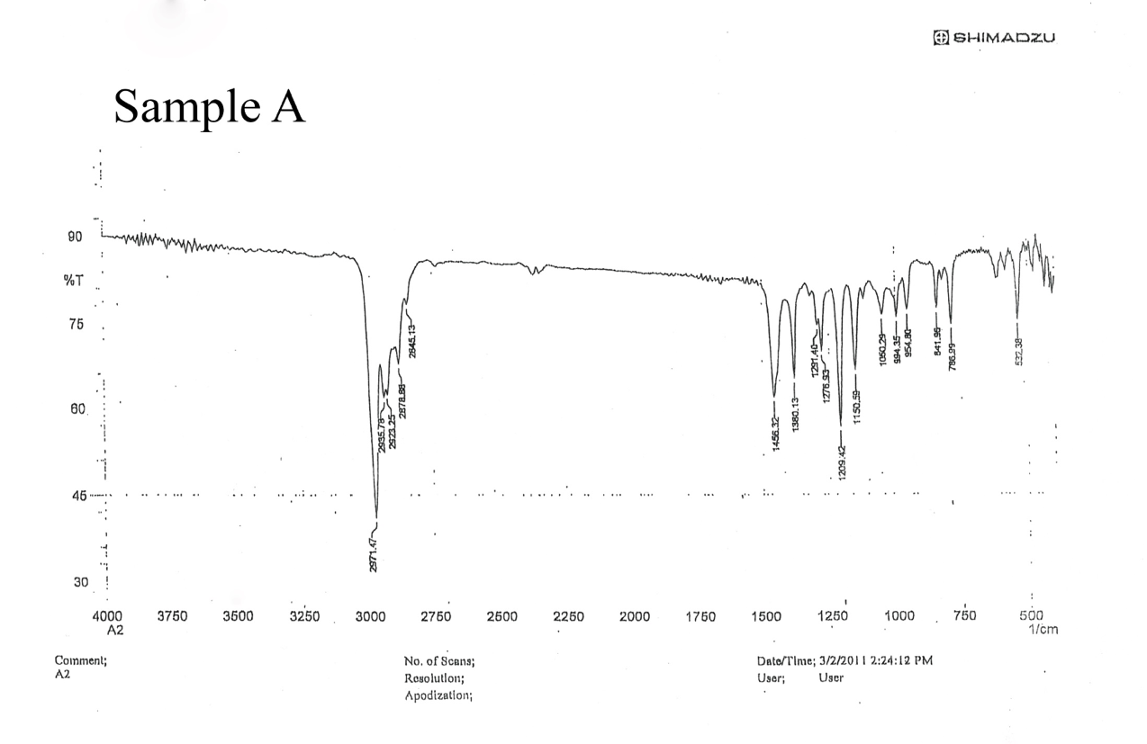

Analysis
In analyzing the NMR spectrum, four different signals can be seen. This means that there are four different types of protons in the unknown “A”. In the next step of analyzing the NMR spectrum, it would be useful to calculate the integration values. The calculated ratio (from left to right) is 1:2:3:3. These values represent the number of protons present at each signal. The number of peaks at each signal were illegible, making it impossible to determine the number of neighboring protons at each signal. Had the number of peaks been legible, the n-1 rule would have been applied to determine the number of neighboring protons. Therefore, the most useful piece of information gathered from the NMR spectrum was that there are four different types of protons with a 1:2:3:3 integration ratio in the unknown.
When analyzing the FTIR, it is important to note that the graph is in units of wavenumber, or 1/cm. There is a major peak at around 3000 cm⁻¹, indicating an alkane. It can also be determined that the compound is not aromatic, given that there is no corresponding peak in an aromatic region of the plot. Additionally, there is a signal at around 500 cm⁻¹ which indicates a C-Br bond.
For the MS spectrum, the molecular ion peak is located around 136 m/z which is the same as a molecular weight of around 136 g/mol.
Conclusion
After analysis of all three plots, it can be concluded that unknown compound “A” is
2-bromobutane (C4H9Br). 2-bromobutane has a molecular weight of 137 g/mol which corresponds to the molecular ion peak found in the MS spectrum. Additionally, a C-Br bond can be seen, in correspondence to the bond that was found in the IR spectrum. The integration values also align to 2-bromobutane, as there are two carbons with three hydrogens, one carbon with two hydrogens, and another with only one hydrogen. This corresponds with the 1:2:3:3 integration ratio. The chemical structure of the compound is as follows:
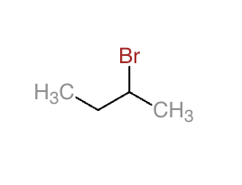
References
Keller L, Joseph K, and Miguel S. 2023 Fall. CHEM 2081 Organic Chemistry II Lab Manual [lab manual]. Auburn (Al): Auburn University.

iChemLabs. ChemDoodle Web Components | Demos > Calculate Molecule Properties. Chemdoodle.com. https://web.chemdoodle.com/demos/calculate-molecule-properties#customise-template.
‌

